**GIT Department of Computer Engineering**

**CSE 222/505 - Spring 2021**

**Homework 4 Report**

**Student Name**

**Samet NALBANT**

**Student Number**

**1801042614**

**CLASS DIAGRAM**

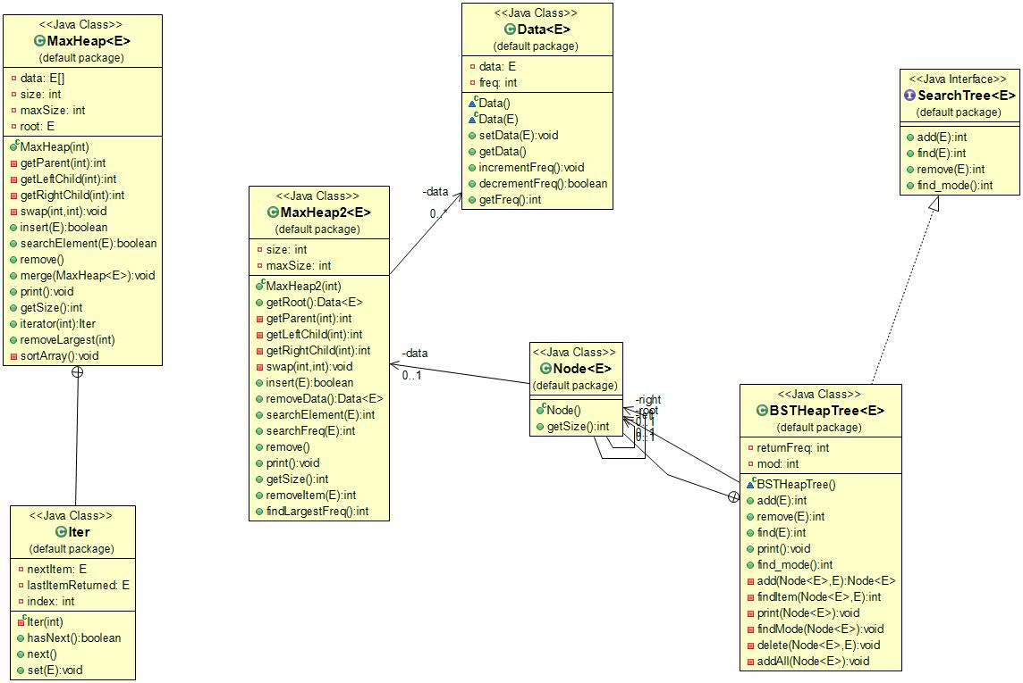

1. **PROBLEM SOLUTION APPROACH**

I create Max Heap class for the part1. After the necessary functions created, I implement the necessary function from the homework file. After I create a new Max Heap2 class for the part2. I create Data class to hold both occurrences and frequencies of the data. After that I create BST Heap Tree Class with necessary functions. Than I implement the other functions. Which wanted in homework pdf file.

1. **TEST CASES**

**Part1)**

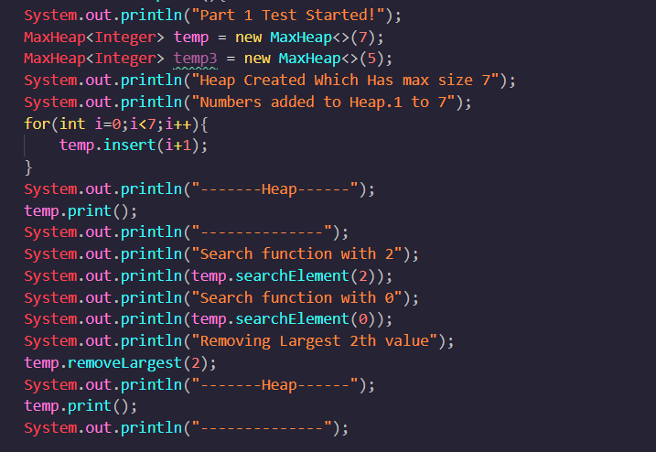

**Part2)**

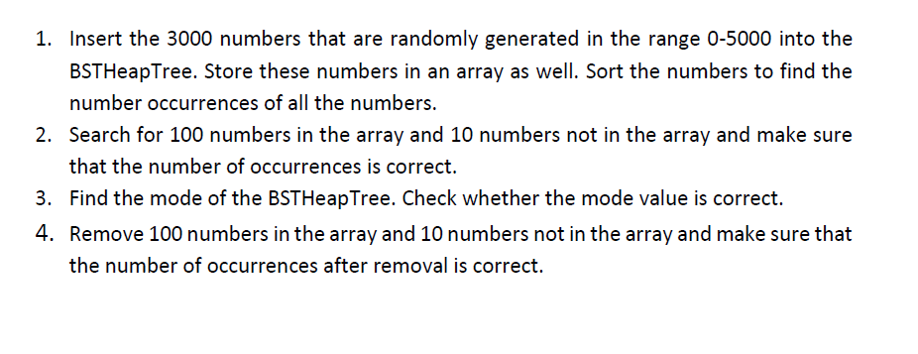

1. **RUNNING AND RESULTS**

